FOR IMMEDIATE RELEASE
15 MARCH 2022

ALLIANZ RENEWS PARTNERSHIP WITH 4-TIME PFL CHAMPION UNITED CITY FOOTBALL CLUB

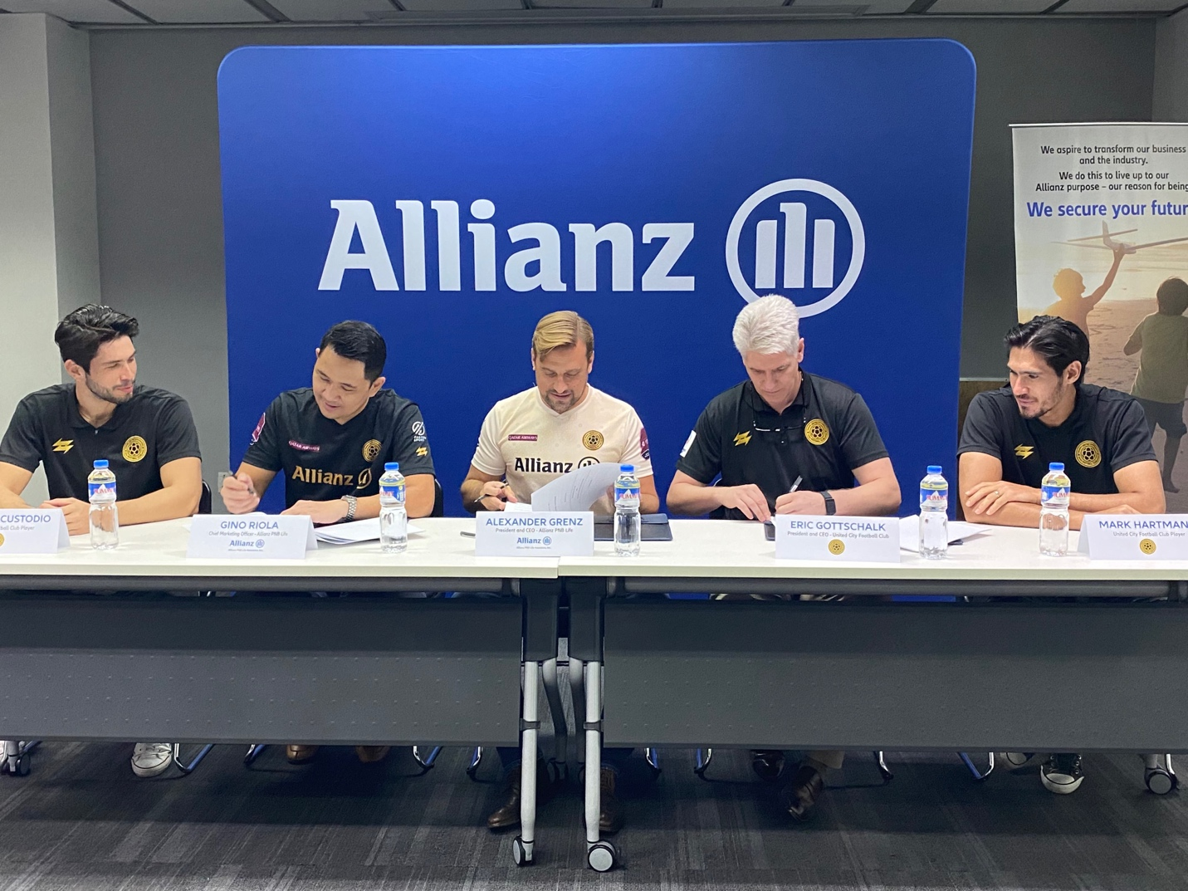

Photo I Caption left to right: Mathew Custodio - United City Football Club (UCFC) player, Gino Riola – Chief Marketing Officer of Allianz PNB Life, Alexander Grenz – President & CEO of Allianz PNB Life, Eric M. Gottschalk - President & Co-Founder United City Football Club (UCFC), & Mark Hartmann - United City Football Club (UCFC)

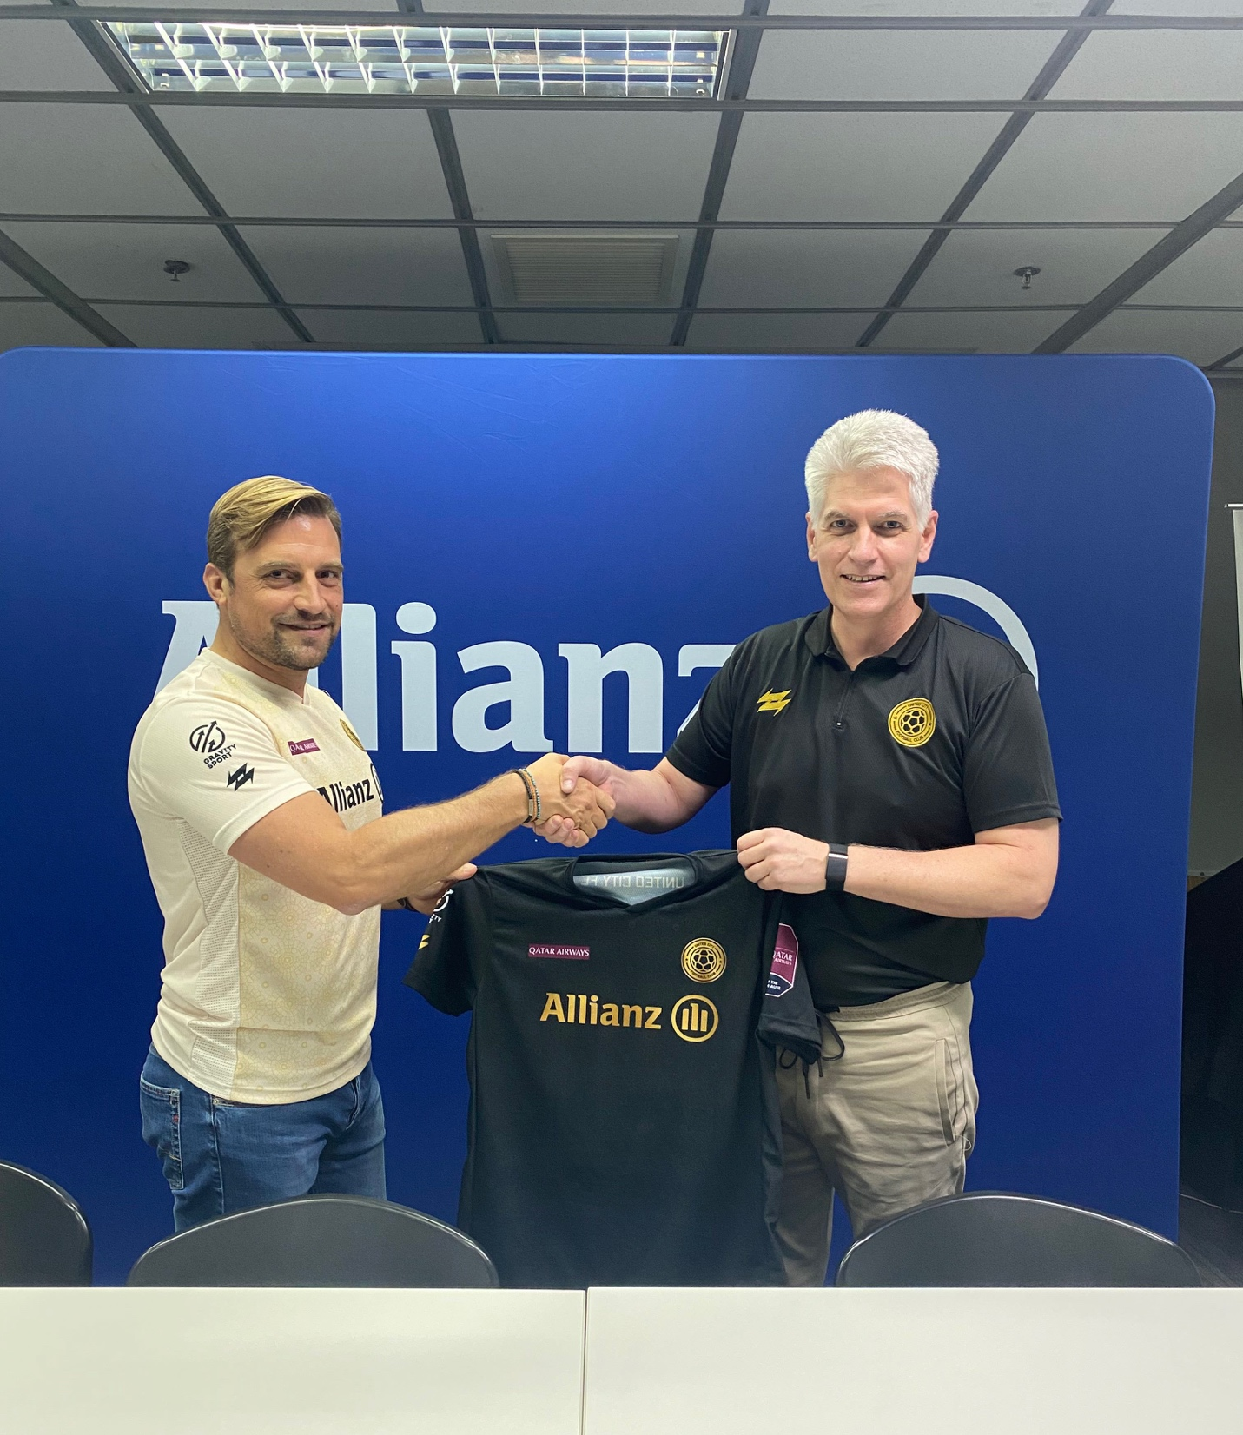
Photo II
Alexander Grenz – President & CEO of Allianz PNB Life, Eric M. Gottschalk - President & Co-Founder United City Football Club (UCFC)

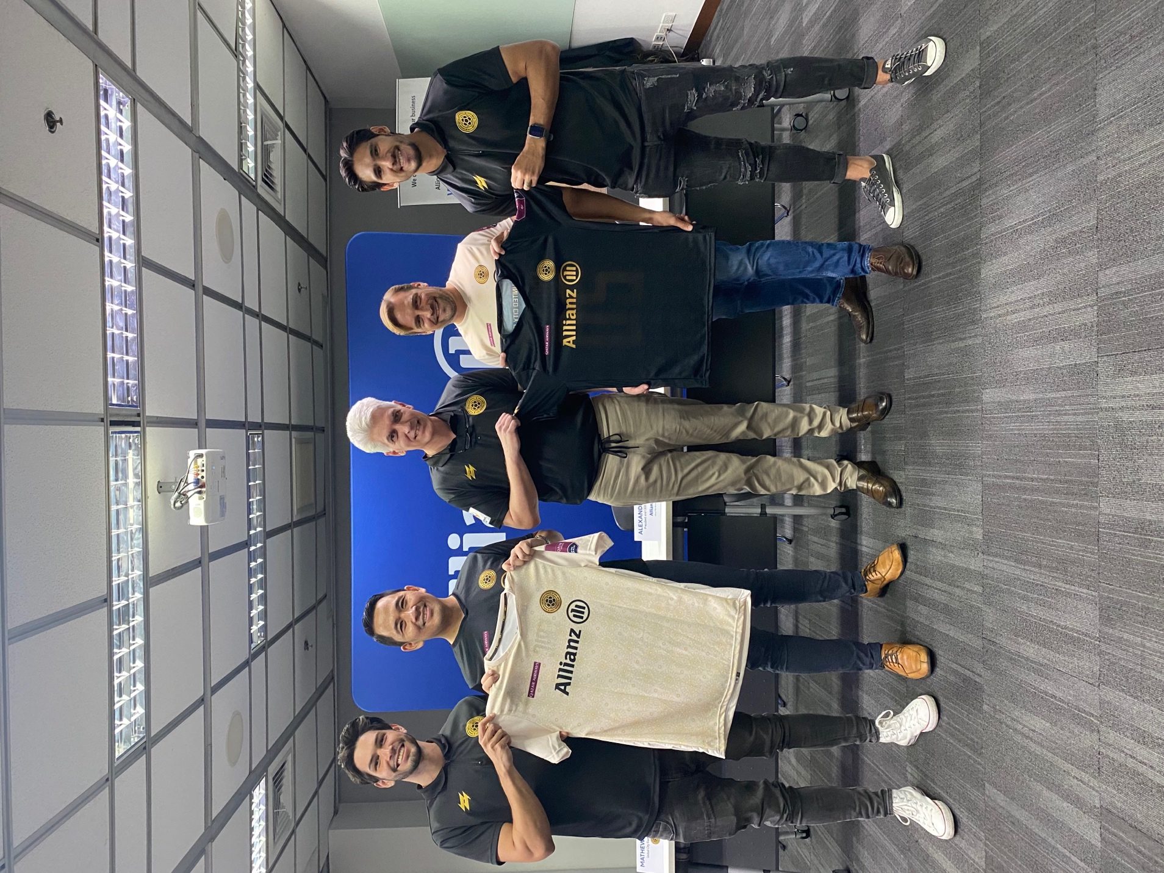

Photo III Caption left to right: Mathew Custodio - United City Football Club (UCFC) player, Gino Riola – Chief Marketing Officer of Allianz PNB Life, Alexander Grenz – President & CEO of Allianz PNB Life, Eric M. Gottschalk - President & Co-Founder United City Football Club (UCFC), & Mark Hartmann - United City Football Club (UCFC)

Allianz PNB Life and the United City Football Club (UCFC) look forward to another year of partnership after the renewal of their contract last March 14, Monday.

“Allianz is very proud to be working with UCFC again, one of the best Filipino football teams in the country,” said Alexander Grenz, President and CEO of Allianz PNB Life. “Globally, we remain dedicated to celebrating the exciting sport of football, and we believe that this partnership will help us in reaching more Filipinos and encouraging a deeper, more fervent interest in this sport.”

Established in 2021, the UCFC is the four-time reigning champion of the Philippines Football League (PFL), one of the most prestigious professional football leagues in the country. The team also became the first Filipino club to enter the group stages of the AFC Champions League in 2021, winning against the Chinese Super League powerhouse Beijing FC with a score of 3:2.

“We are very grateful to Allianz for their continued support,” said Eric Gottschalk, President and co-founder of UCFC. “In spite of the difficulties we have faced because of the pandemic, interest for the sport here in the Philippines only keeps growing, and we believe partnering with Allianz will amplify the awareness and enthusiasm for football.”

Allianz PNB Life, on the other hand, has been a long-time supporter of football and futsal. Together with UCFC, the Department of Education (DepEd), and the Moran Foundation, Allianz recently launched a nationwide online challenge for young Filipino amateur football and futsal players called “Kickoff!: The Allianz PNB Life Virtual Football and Futsal Mastery Challenge”, where they can showcase their ball mastery skills via social media. Allianz also won a silver award for its National Youth Futsal Invitational (ANYFI) at the Sports Industry Awards Asia in 2019, and supported the 10th ASEAN Para Games bid of the Philippines’ first cerebral palsy football team, the CP Rascals.

“We have always believed and proudly supported Filipino athletes, and we will continue to do so in both the local and global stages,” stated Grenz. “This partnership with UCFC is further proof of our commitment to empower and enable Filipino athletes in their goal to achieve greater heights and bring pride to the Philippines.”

***

ABOUT UCFC: United City Football Club (UCFC) is a SEC registered Filipino Professional Football Club that aims to promote and build values such as equality, diversity, leadership through sports.

UCFC is a member of the Philippines Football League (PFL), the Philippines' professional level of men's club football in the country. The Club is currently the 4x defending national champion in the PFL and the first Philippine team to qualify and to win a match on the AFC Champions League level when the team featured against Beijing FC during the AFC Champions League Group stages in Tashkent, Uzbekistan.

As a mission, the Club stands to help re-invigorate young athletes, families, and the local community through discipline, hard work, and passion. The ambition is to be the best of the best in Asia - be it on the football field, esports, or within the community - and provide a pathway and equal opportunities for the next generation of young talent in their pursuit of sporting & educational excellence.

The Club recently announced its move to the Pampanga / Tarlac region, where it plans to set up its youth football academy in Clark City and to and build its football stadium while making use of the already existing stadium facilities in New Clark City in the meantime.

As part of the move, United City FC will be renamed to United Clark FC by the end of 2021, while its Esports division will simply be called UCFC Esports.

The UCFC Esports division was successfully launched in June 2021 and currently features three professional teams participating in titles such as Valorant, League of Legends: Wild Rift as well as E-football (PES / FIFA), with more teams such as "Mobile Legends" etc. to be added in 2022.

Media Contact:

Liz Sarte:

liz@unitedcityfootballclub.com or media@unitedcityfootballclub.com

